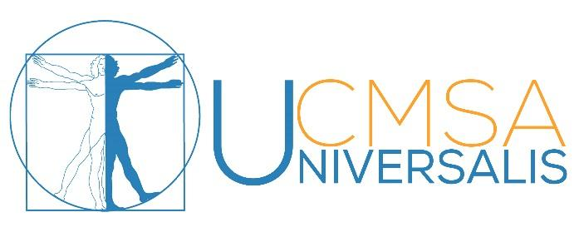

AGENDA AUDIT GA FALL 15th November 2017
- Rules of the GA
- Agenda
- Minutes from previous GA
- Audit and Semester Report
- Statutes
- New Candidate Committee
- New IB
- Motions
- Questions
- Updates
  - Opening Board Positions
  - Education Prize
  - Upcoming Events
- Drinks and Snacks

